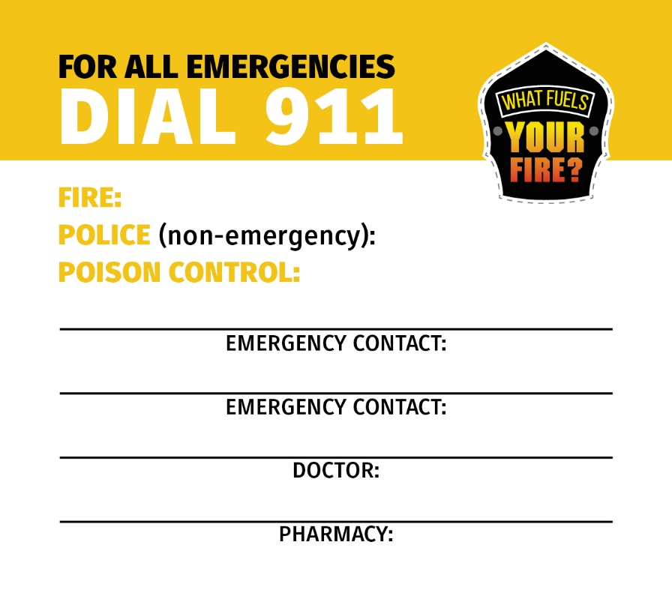

222-222-2222

222-222-2222

222-222-2222