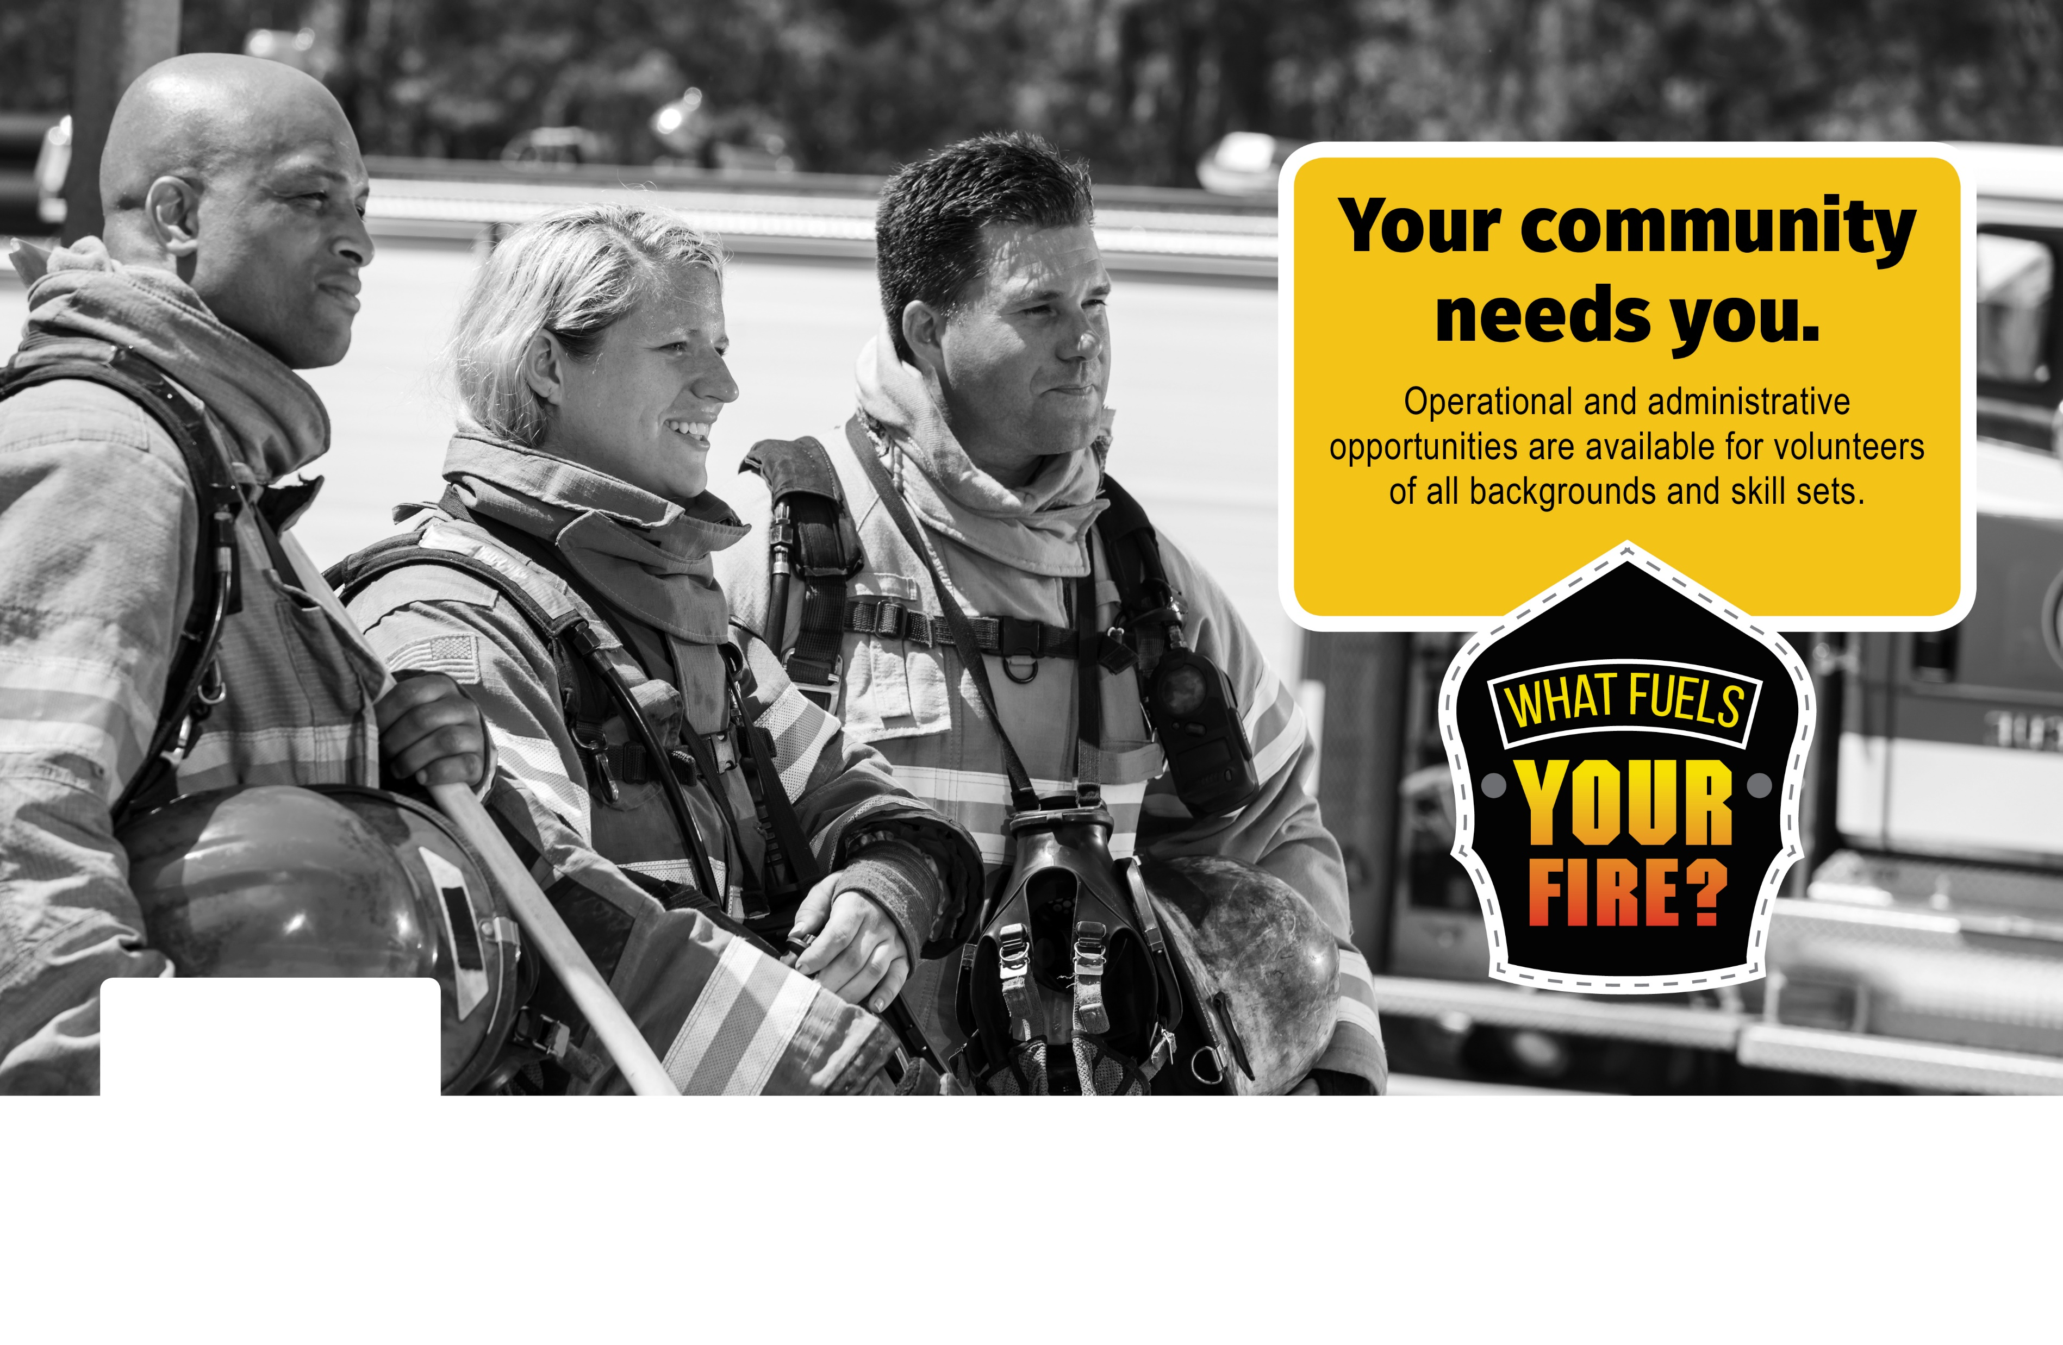

**222-222-2222**

**www.WebsiteHere.com**

**BE A TYPE-JURISDICTION-NAME-HERE**

**VOLUNTEER FIREFIGHTER. JOIN TODAY!**