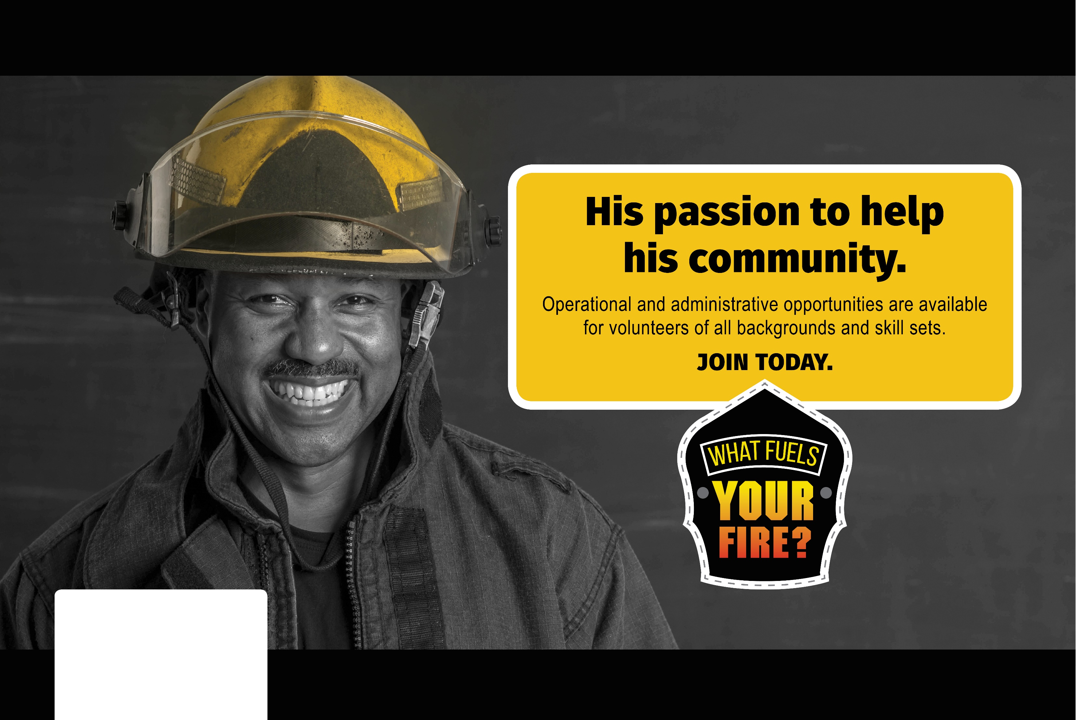

VOLUNTEER TODAY! 222-222-2222 | www.WebsiteHere.com

Type-Your-Jurisdiction-Name-Here Department wants to know what fuels YOUR fire?