Matthew R. Goldstein
Fire Chief (Retired)
United States Coast Guard
BASE Elizabeth City, North Carolina
Chief Goldstein’s fire service career spanned 38 years. He served his community as a volunteer firefighter for five years. He served his country as both an Active-Duty US Air Force Fire Protection Specialist for four years and twenty-nine years in civilian Civil Service.
Chief Goldstein’s federal service began in July of 1990 as an Active-Duty Air Force Fire Protection Specialist. He attended Apprentice Fire Protection Specialist training at Chanute AFB, Rantoul, IL in November 1990. First and only duty assignment was at MacDill AFB, Tampa, FL. During his tenure at MacDill he had two Temporary Duty Assignments: Ten months assigned to 4402nd Support Squadron, JTF-Bravo, Soto Cano Honduras and a 4 month assignment supporting 55th Wing deployed to Naval Support Activity (NSA) Souda Bay, Crete Greece. He was Honorably Discharged in July of 1994.
Chief Goldstein began his Civil Service career returning as a Firefighter/Driver Operator and Lead Firefighter at NSA Souda Bay. He then served as Lead Firefighter at NSA Mid-South, Millington, TN. He served multiple positions in the European theater and Continental United States at US Navy and Marine Corps bases. He retired from Civil Service on November 30, 2023, from his position as the Fire Chief of US Coast Guard BASE Elizabeth City, NC.
Chief Goldstien’s Military and Civilian Awards include Joint Service Achievement Medal, Secretary of Defense Medal for Global War on Terrorism Civilian Service Medal, US Coast Guard Civilian Service Commendation Medal, and the US Coast Guard Meritorious Team Commendation Medal (multiple awards). Chief Goldstein was awarded Civilian Fire Officer of the Year (2015) by the Commander of Navy Installations Command.
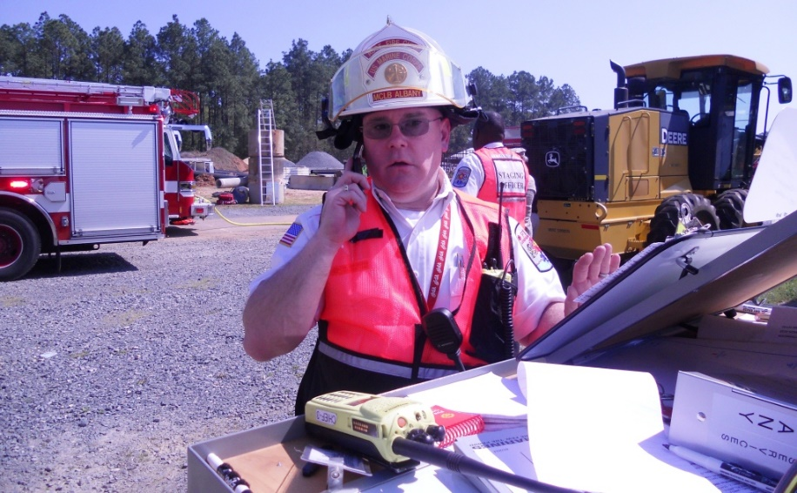
Chief Goldstein lives by the motto, “service before self!”.

