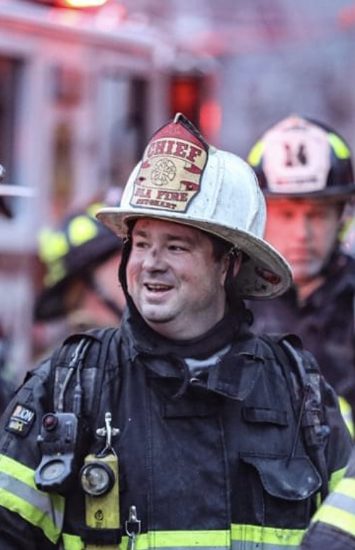
Chief Barry J. Shughart is a highly experienced firefighter with over three decades of dedicated service. He began his firefighting career as a volunteer firefighter in 1992 in Mt. Holly Springs, Pennsylvania, and has since climbed through various ranks and roles. His impressive journey includes positions like Junior Firefighter, Paramedic Supervisor, Captain, and Assistant Fire Chief, culminating in his current role as Fire Chief.

In addition to his firefighting career, Chief Shughart served in the Department of Defense as a Paramedic and Firefighter/Paramedic at various locations, earning promotions along the way. He's known for his exceptional leadership, especially during the COVID-19 pandemic.

Chief Shughart is a highly educated professional, holding a Master of Business and Public Administration and a Bachelor of Science in Public Administration. He also has numerous certifications, including Chief Fire Officer and Chief EMS Officer.

Outside of work, Chief Shughart is deeply connected to his community, serving as both the President and Assistant Fire Chief of his hometown volunteer fire department. He's also involved in various organizations and enjoys outdoor activities like hiking, camping, hunting, fishing, and SCUBA diving.

