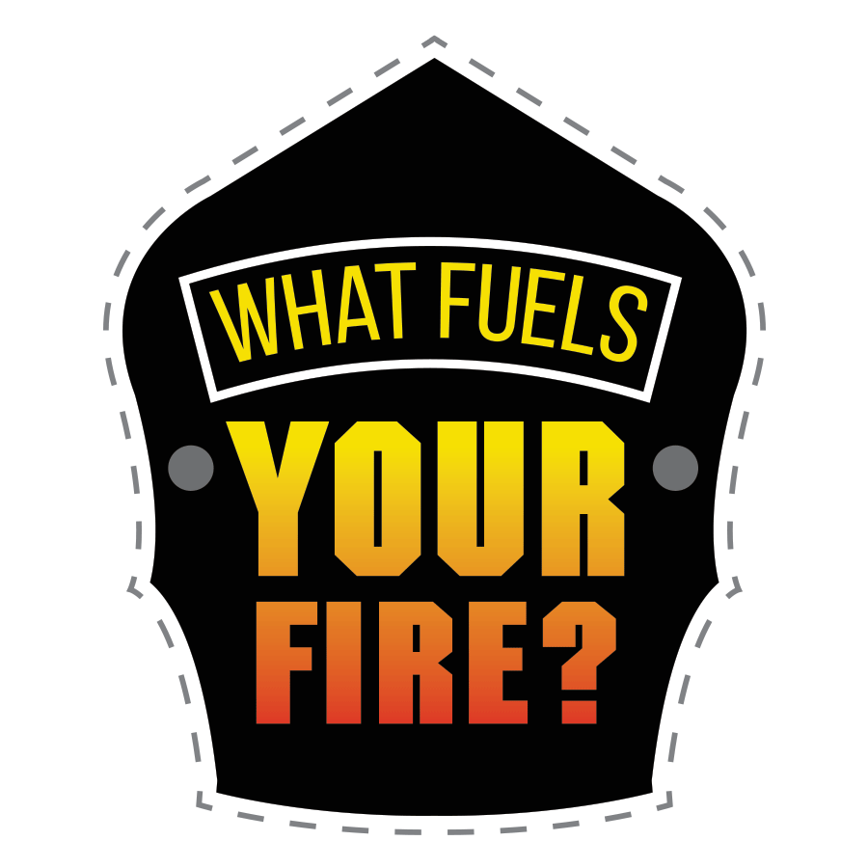

Individual Questions

Background
The following is a draft of the questions that are in the survey so that you can easily print and read prior to implementing the survey or interpreting the data. We have also included by each question a value that will correspond to the variable name for each of the sections of the report. For example:

How likely is it that you could find a job with another department with about the same
pay and/or benefits you have now? [intent_3]

This means that this question would be part of the analysis for the section on a respondent’s intent to leave the department. You can find the codebook for these variables in the last section of the Data Analysis for Climate Survey Guide.

Survey Questions

Respondent Professional Characteristics

Q2 What is your designation at your current fire department? [career]

[1] Career Full-time
[2] Career Part-time
[3] Volunteer

Q3 What is your current rank in the department? [rank]

[1] Probationary firefighter
[2] Firefighter
[3] Driver engineer
[4] Lieutenant
[5] Captain
[6] Battalion Chief
[7] Division Chief
[8] Deputy Chief
[9] Assistant Chief
[10] Fire Chief
[11] Other (Please specify) [rank_11_Text]

Q4 Are there opportunities for volunteer firefighters to be promoted in your department? [promote]

[1] Yes (if yes, continue to Q5)
[2] No (if no, continue to Q6)

Q5 If you are in a combination fire department, can volunteer firefighters outrank career firefighters? [outrank]

[1] Yes
[2] No

Why are you a firefighter?

Q6 How many of your family members were firefighters before you became a firefighter? (if none, please answer 0) [family]
Open-ended responses

Q7 How many of your close friends were firefighters before you became a firefighter? (if none, please answer 0) [friends]
Open-ended responses

Commitment to the Department

Q8 We would like to ask a few questions about how much you like working in your current department. Please respond to the following statements on a scale from 1-7 with 1 = “strongly disagree” and 7 = “strongly agree”.

 | Strongly Disagree (1) | Moderately  Disagree (2) | Slightly disagree (3) | Neither agree nor disagree (4) | Slightly agree (5) | Moderately  Agree (6) | Strongly agree (7)
1. I would be happy to spend the rest of my career with this department. [commit_1]
2. I enjoy discussing my department with people outside it. [commit_2]
3. I really feel as if this department’s problems are my own. [commit_3]
4. I think that I could easily become as attached to another department as I am to this one (R). [commit_4]
5. I do not feel like ‘part of the family’ at my department (R).
[commit_5]
6. I do not feel ‘emotionally attached’ to this department. (R) [commit_6]
7. This organization has a great deal of personal meaning for me. [commit_7]
8. I do not feel a strong sense of belonging to my department. (R) [commit_8]
(Affective Commitment Scale from Allen, N. J., & Meyer, J. P. (1990). The measurement and antecedents of affective, continuance, and normative commitment to the organization. Journal of Occupational Psychology, 63, 1–18. (R) indicates items that need to be reverse coded. Perform factor analysis on commit_1 through commit_8 after reverse coding.)

Intention to Leave

Q9 The following are some statements about you and your position in the department. How much do you agree or disagree with each statement?

 | Strongly Disagree (1) | Moderately  Disagree (2) | Slightly disagree (3) | Neither agree nor disagree (4) | Slightly agree (5) | Moderately  Agree (6) | Strongly agree (7)
1. I will probably look for a new department in the next year. [intent_1]
2. I often think about quitting [intent_2]

Q10 Please answer the following question on a scale from 1-7 with 1= “not at all likely” and 7= “extremely likely”.

How likely is it that you could find a job with another department with about the same pay and/or benefits you have now? [intent_3]

[1] Not at all likely
[2]
[3] somewhat likely
[4]
[5] Quite likely
[6]
[7] Extremely likely
****Q9 and 10 from Cammann, C., Fichman, M., Jenkins, G. D., & Klesh, J. (1983). Assessing the Attitudes and Perceptions of organizational members. In Assessing Organizational Change: A Guide to Methods, Measures, and Practices (pp. 71–138). New York: Wiley. – Add responses from intent_1, intent_2, intent_3 (range of 3-21). Lower scores indicate greater organizational commitment (Michigan Organizational Assessment)

Personal View of Diversity in the Department

Q11 There has been a lot of discussion lately about increasing diversity in the fire service. Do you think your department should invest more resources in recruiting a diverse team? [invest]

[1] Yes
[2] No

Q12 What does diversity mean to you? [define]

Open-ended responses
Q13 How satisfied or dissatisfied are you with the overall climate/environment that you have experienced at your department within the past 12 months? [environment]
[1] Very dissatisfied
[2] Moderately dissatisfied
[3] Slightly dissatisfied
[4] Neither satisfied nor dissatisfied
[5] Slightly satisfied
[6] Moderately satisfied
[7] Extremely satisfied

Q14 How important is a diverse team to the operation of your fire department? [diverseteam]

[1] Not important
[2] Slightly important
[3] Moderately important
[4] Very important
[5] Extremely important

Q15 How helpful would it be to have the following groups better represented in your department?
Please answer on a scale from 1-5 with 1= “not very helpful” and 5 = “very helpful”.

 | Not very helpful (1) | (2) | (3) | (4) | Very helpful (5)
1. Women [represent_1]
2. White [represent_2]
3. Black or African-American [represent_3]
4. American Indian or Alaska Native [represent_4]
5. Asian [represent_5]
6. Native Hawaiian or Other Pacific Islander [represent _6]
7. LGBTQ+ Individuals [represent _7]
8. Older Adults [represent _8]
9. Younger Adults [represent_9]
10. Individuals who speak a language or languages in addition to English (please specify languages) _____________ [represent_10]
***[represent_10_TEXT] is open text specification of languages for represent_10

Q16 The following statements refer to your own experience in your department. Please indicate how much you disagree or agree with the following statements.

 | Completely disagree (1) | (2) | (3) | (4) | Completely agree (5)
1. My experiences since coming to this department have led me to become more understanding of racial/ethnic differences. [experience_1]
2. The fact that the department is made up of people of many different races and ethnicities has a positive impact on the department’s culture. [experience_2]
3. Getting to know people with racial/ethnic backgrounds different from my own has been easy at this department. [experience_3]
*** questions from the University of Maryland Diversity Survey

Q17 The following questions refer to the overall climate at your department. Please respond to the following questions on a scale from 1-5.

 | To a very small extent (1) | To a small extent (2) | Somewhat (3) | To a large extent (4) | To a very large extent (5)
1. Are men and women treated equally at your department? [climate_1]
2. Is there a space for employees of different race and religion? [climate_2]
3. Is there space for elderly employees? [climate_3]
4. Is there space for employees with various illnesses or disabilities? [climate_4]
***Items from the COPSOQ II Scale for Social Responsibility – Item scoring 1=0, 2=25, 3=50, 4=75, 5=100. Need to recode the responses to the item scoring and then calculate the average response across all four questions). Higher responses indicate higher levels of social responsibility in the organization.

Q18 We would like to know more about the organization’s support for diversity. Please respond to the following statements on a scale from 1-7 with 1 = “strongly disagree” and 7 = “strongly agree”. (on next page)
 | Strongly Disagree (1) | (2) | (3) | Neither agree or disagree (4) | (5) | (6) | Strongly agree (7)
1. Department leadership communicates consistent messages with regard to diversity [orgsupport_1]
2. Department leadership encourages diversity. [orgsupport_2]
3. Department leadership shows that diversity is important through its actions. [orgsupport_3]
4. This department is committed to diversity. [orgsupport_4]
5. This department respects individuals and values their differences. [orgsupport_5]
6. This department is making progress with diversity initiatives. [orgsupport_6]
7. Team members of different ages are valued equally by this department. [orgsupport_7]
8. My supervisor is committed to, and supports, diversity. [orgsupport_8]
9. My supervisor handles diversity matters satisfactorily. [orgsupport_9]
10. Firefighters in this department appreciate others whose race/ethnicity is different from their own. [orgsupport_10]
11. Firefighters in this department appreciate others of the opposite sex. [orgsupport_11]
12. Education about diversity will enhance the department’s ability to fulfill its mission. [orgsupport_12]
13. This department has done a good job providing training programs that promote multicultural understanding. [orgsupport_13]
Inclusion

Q19 Next, we would like to know more about how inclusive your department is with regard to processes, decisions, and opportunities. Please read the following statements and indicate your agreement on a scale of 1-7 with 1= “strongly disagree” and 7 = “strongly agree”.

 | Strongly Disagree (1) | Disagree (2) | Somewhat disagree (3) | Neither agree nor disagree (4) | Somewhat agree (5) | Agree (6) | Strongly agree (7)
1. Coworkers are treated as valued members of the team without losing their unique identity. [inclusive_1]
2. I feel excluded from my coworkers because I am different. [inclusive_2]
3. Within my group, I am encouraged to share ideas on processes and improve the department. [inclusive_3]
4. I feel like my shift mates and I are empowered to make decisions as it relates to internal issues that need resolution. [inclusive_4]
5. Training opportunities, awards, and recognition are fairly distributed among the members of the department.
[inclusive_5]
6. The decision making process that impacts my job is fair [inclusive_6]
7. Promotions are made on what you know, rather than who you know. [inclusive_7]
8. All employees have an equal opportunity for promotion. [inclusive_8]
9. I experience resistance when I suggest new ideas for improving our organization. [inclusive_9]

Discrimination, Bullying, Hazing

Q20 The following statements regard discrimination and bullying in the department. Please indicate your level of agreement with each of the following statements on a scale of 1-7 with 1= “strongly disagree” and 7= “strongly agree.”

 | Strongly Disagree (1) | (2) | (3) | Neither agree or disagree (4) | (5) | (6) | Strongly agree (7)
1. I have personally witnessed discrimination in this department. [bullying_1]
2. I have been the victim of discrimination in this department. [bullying_2]
3. This department takes claims of discrimination seriously. [bullying_3]
4. I have personally witnessed bullying in this department. [bullying_4]
5. I have been the victim of bullying in this department. [bullying_5]
6. This department takes claims of bullying seriously. [bullying_6]
7. I have personally witnessed hazing in this department. [bullying_7]
8. I have been the victim of hazing in this department. [bullying_8]
9. This department takes claims of hazing seriously. [bullying_9]
10. Racial, ethnic, and gender-based jokes are not tolerated at this department. [bullying_10]

Q21 Over the past 12 months, how often have you experienced discriminatory events at your department because of your…

 | Never (1) | 1-2 times (2) | 3-4 times  (3) | 5 or more times (4)
1. Racial or ethnic identity [discriminate_1]
2. Sex [discriminate_2]
3. Sexual orientation [discriminate_3]
4. Gender identity or gender expression [discriminate_4]
5. Veteran status [discriminate_5]
6. Marital status [discriminate_6]
7. National origin [discriminate_7]
8. Age [discriminate_8]
9. Religion [discriminate_9]
10. Height or Weight [discriminate_10]
11. Political orientation [discriminate_11]
12. Social class [discriminate_12]
13. Ability or disability status [discriminate_13]
*** U. of Mich Diversity and Inclusion Staff Survey

Q22 Did you report these discriminatory/harassment events? [report]

Open-ended response

Influence and Fairness

Q23 Now we have a few questions about how much you believe you and other team members are included in decision making within the department. Please respond to the following statements on a scale from 1-5 with 1= “Never” and 5 = “Always”.
 | Never (1) | Seldom (2) | Sometimes (3) | Often (4) | Always (5)
1. Do you have a large degree of influence concerning your work? [decisions_1]
2. Do you have a say in choosing who you work with? [decisions_2]
3. Can you influence the amount of work assigned to you? [decisions_3]
4. Do you have any influence on what you do at work? [decisions_4]
***Items from the COPSOQ II Scale for Influence at Work Scale – Item scoring 1=0, 2=25, 3=50, 4=75, 5=100. Need to recode the responses to the item scoring and then calculate the average response across all four questions). Higher responses indicate higher levels of influence in the organization.
Fairness

Q24 Next, we would like to have more information about how fairly team members are treated in your department. Please respond to the following statements on a scale from 1-5 with 1 = “completely disagree” and 5 = “completely agree”.

 | Completely disagree (1) | (2) | (3) | (4) | Completely agree (5)
1. People are promoted fairly in this department [fairness_1]
2. My work is recognized and appreciated by the leaders. [fairness_2]
3. I am treated fairly at my workplace. [fairness_3]
4. Conflicts are resolved in a fair way. [fairness_4]
5. The work is distributed fairly. [fairness_5]
6. Standards and rules are applied equally. [fairness_6]
7. Promotional opportunities are provided fairly. [fairness_7]
8. New opportunities are provided fairly. [fairness_8]
*** Questions adapted from COPSOQ II Rewards Kristensen, T. S., Hannerz, H., Hogh, A., & Borg, V. (2005). The Copenhagen Psychosocial Questionnaire-a tool for the assessment and improvement of the psychosocial work environment. Scandinavian Journal of Work Environment and Health, 31(6), 438–449.

Leadership

Q25 Please indicate your level of agreement with the following statements about leadership in your department.

 | Strongly disagree (1) | Somewhat disagree (2) | Neither agree nor disagree (3) | Somewhat agree (4) | Strongly agree (5)
1. There are processes in place to facilitate the sharing of information throughout the department. [leadership_1]
2. My supervisor/the chief has clearly explained what is expected of me in my work. [leadership_2]
3. I feel comfortable sharing my issues/negative feedback with my immediate supervisor/leadership. [leadership_3]
4. My immediate supervisor treats me fairly. [leadership_4]
5. My supervisor acts in the organization’s best interest. [leadership_5]
6. I feel the chief/leadership follows through on promises/commitments they make. [leadership_6]
7. My Chief listens to the concerns of the department’s members. [leadership_7]
8. My Chief has communicated a clear vision for the future of the department. [leadership_8]
9. My superior makes me feel like a valued member of the team. [leadership_9]

Team Factors

Q26 You are almost finished! This next section is focused on your team within the fire department and how well they work together.

 | Never (1) | Seldom (2) | Sometimes (3) | Often (4) | Always (5)
1. Is there a good atmosphere between you and your colleagues? [team1]
2. Is there good cooperation between the colleagues at work? [team2]
3. Do you feel part of a community at your place of work? [team3]
***COPSOQ II Social Community at work 1=0, 2=25, 3=50, 4=75, 5=100 – recode

Q27 The next questions are not about your own job, but about the workplace as a whole.

Please respond to the following statements on a scale from 1-5 with 1= “to a very small extent” and 5 = “to a very large extent”.

 | To a very small extent (1) | To a small extent (2) | Somewhat (3) | To a large extent (4) | To a very large extent (5)
1. Do the firefighters withhold information from each other? (R) [teamwork_1]
2. Do the firefighters withhold information from the management? (R) [teamwork_2]
3. Do the employees in general trust each other? [teamwork_3]
4. Does the management trust the employees to do their work well? [teamwork_4]
5. Can you trust the information that comes from the management? [teamwork_5]
6. Does the management withhold important information from the employees?(R) [teamwork_6]
7. Are the employees able to express their views and feelings? [teamwork_7]
***COPSOQ II 36.10 Trust – (R) denotes that responses need to be reversed coded before analysis – Questions 1, 2, and 3 measure horizontal trust. Questions 4, 5, 6, and 7 measure vertical trust.

Conflict and Ostracism

Q28 Before we get to the final section of the survey concerning your demographics, we just have a few questions about conflict within your department.
Please answer the following questions on a scale of 1-5 with 1 = “none” and 5 = “ a great deal”.

 | None (1) | (2) | (3) | (4) | A great deal (5)
1. How much anger is there among the members of the department? [conflict_1]
2. How much personal friction is there in the department during decisions? [conflict_2]
3. How much tension is there in the department during decisions? [conflict_3]
4. How many disagreements over different ideas are there? [conflict_4]
5. How many differences about the content of decisions does the department have to work through? [conflict_5]
6. How many differences of opinions are there within the department? [conflict_6]
*** Pearson, A. W., Ensley, M. D., & Amason, A. C. (2002). An assessment and refinement of Jehn’s intragroup conflict scale. International Journal of Conflict Management, 13(2), 110–126. – modified to make present tense rather than project based

Q29 The following statements refer to the inclusiveness of your teammates. Please indicate how often the following scenarios occur in your department on a scale from 1 to 7 with 1 = “Never” and 7 = “Always”
 | Never (1) | Once in awhile (2) | Sometimes (3) | Fairly often (4) | Often (5) | Constantly (6) | Always (7)
1. Others ignored you at work. [ostracism_1]
2. Others left the area when you entered. [ostracism_2]
3. Your greetings have gone unanswered at work. [ostracism_3]
4. You involuntarily sat alone in a crowded lunchroom at work. [ostracism_4]
5. Others avoided you at work. [ostracism_5]
6. You noticed others would not look at you at work. [ostracism_6]
7. Others at work shut you out of the conversation. [ostracism_7]
8. Others refused to talk to you at work. [ostracism_8]
9. Others at work treated you as if you weren’t there. [ostracism_9]
10. Others at work did not invite you or ask you if you wanted anything when they went out for a coffee break/lunch/dinner. [ostracism_10]
*** Ferris, D. L., Brown, D. J., Berry, J. W., & Huiwen Lian. (2008). The Development and Validation of the Workplace Ostracism Scale. Journal of Applied Psychology, 93(6), 1348–1366. https://doi.org/10.1037/a0012743

Demographics
Q30 How many years have you been in the overall fire profession? [overallyears]
Open-ended responses
Q31 How many years have you been at your current department? [tenure]
Open-ended responses
Q32 What is your current education level? [educ]
[1] Less than high school
[2] High school graduate
[3] Some college/vocation school
[4] College graduate
[5] Graduate degree

Q33 How old are you in years? [age]
Open-ended responses

Q34 What is your marital status? [status]

[1] Single
[2] Living with a partner
[3] Married
[4] Married/separated
[5] Divorced

Q35 What is your gender/gender preference? [gender]

[1] Male
[2] Female
[3] Transgender/gender non-conforming
[4] Other/prefer not to answer

Q36 Are you Hispanic, Latino, or of Spanish origin? [hispanic]

[1] Yes
[2] No

Q37 To which of the following ethnic groups do you belong and identify? [ethnicity]

[1] White
[2] Black or African American
[3] American Indian or Alaskan Native
[4] Asian
[5] Other (please specify) [ethnicity_5_TEXT]

Q38 Were you born in the United States? [born]

[1] Yes
[2] No

Q39 In which country were you born? [whereborn]
Open-ended responses

Q40 Please indicate your generation status. [generation]

[1] All of my grandparents and both of my parents were born in the United States.
[2] Both of my parents were born in the United States.
[3] One of my parents was born in the United States.
[4] Neither of my parents were born in the United States.

Q41 What was your individual total income from your base pay salary before taxes for the year of 2018? [income]

[1] Less than $30,000
[2] $30,000-54,999
[3] $55,000-79,999
[4] $80,000-104,999
[5] $105,000-129,999
[6] More than $130,000
Q42 What was your total household income from your base pay salary before taxes for the year of 2018? [householdincome]
[1] Less than $30,000
[2] $30,000-54,999
[3] $55,000-79,999
[4] $80,000-104,999
[5] $105,000-129,999
[6] More than $130,000
Q43 Do you have additional comments about diversity and inclusion within your department? [department]
Open-ended responses
Q44 Do you have additional comments about diversity and inclusion within the fire service? [fireservice]
Open-ended responses

