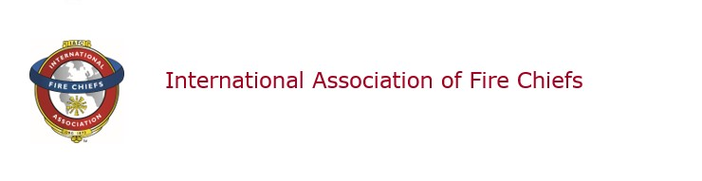

VCOS Board Telecon
08 February2022

Participants:

IAFC Board Members Present:
Chief Chuck Flynn, Chair
Chief Rich Cowger, Vice Chair
Chief Paul Sterling, Board Member at Large
Chief Brita Horn, Board Member at Large
Chief Jim Cook, Board Member at Large
Chief Norvin Collins, Board Member at Large
Chief Kevin Hardwick, Board Member at Large
Chief Jason Catrambone, Board Member at Large
Chief Al Yancy, Board Member at Large

IAFC Board Members Not Present:
Chief Fred Windisch, Secretary/Treasurer

IAFC Guests/Staff:
Mr. Kevin McGee, Chief Operations Officer

Call to Order

Chief Flynn chaired the meeting. A roll call was taken and a quorum was present. The meeting came to order at 1401 hrs ET.

Approval of December 2021 Minutes
Chief Chuck Flynn, Chair

MOTION: 08 FEB 2022-01
Motion made and seconded to approve the January 2022 minutes. Motion carried.
COWGER/HORN
.

International Director’s Report
Chief Catrambone, International Director

Chief Catrambone was requested to serve on the IAFC Communications Committee.

New Business

The Board reviewed the February 18-19, 2022 meeting agenda draft to assure that agenda items have sufficient time. The morning session on February 19 was adjusted for accuracy of time for each agenda item.

Discussion occurred regarding the logistics for the meeting to include plans for ground transportation and audio-visual needs.

Discussion occurred regarding information that the BOD prefers to consider the requests from the two IAFC 2022 2nd VP candidates for a VCOS endorsement. Consideration and the decision making for endorsement will occur during the February 18-19, 2022 Board meeting.

The telecon ended at 1446 hrs ET.

Minutes submitted by:

Mr. Kevin McGee
Interim VCOS Staff Liaison

Fire Chief Chuck Flynn
VCOS, Chair

Because electronic mail can be altered, the integrity of this communication cannot be guaranteed.

