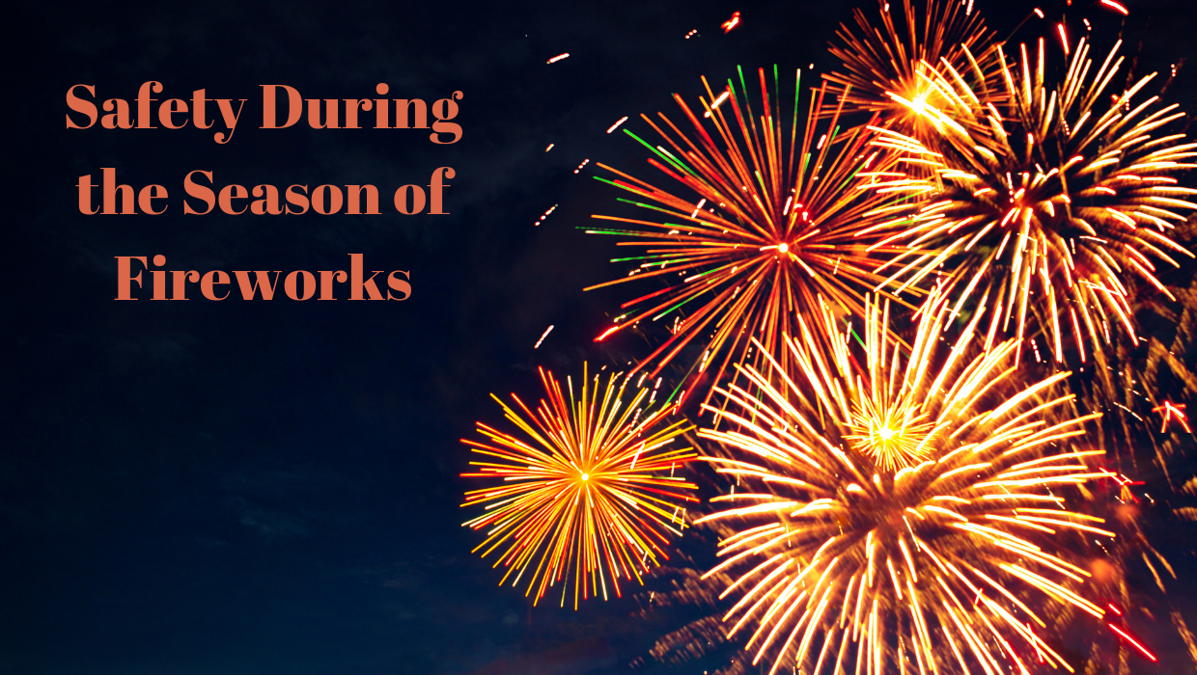

Crackle Pop: July 4 Firework Festivity Safety

Fireworks are an enchanting way to celebrate holidays, and no day in the U.S. lays quite the claim to fireworks as the Fourth of July. For many, a quintessential July night is spreading out with a picnic blanket on the grass and watching bright colors burst with a bang, leaving shimmering trails of light across the night sky.
Fireworks are beautiful, but consumer fireworks — those purchased by the public for general use — have a dangerous side. When not handled by experts, fireworks can cause burns, other severe injuries, fires, and even death. Two in five fires started by fireworks are reported on Independence Day, and, according to the Consumer Product Safety Commission, an average of 280 people go to the emergency room every day with fireworks-related injuries in the month around this holiday.
In North Carolina neighborhoods it is common to hear the pops and bangs of fireworks on any given weekend night in the weeks leading up to and following the Fourth of July. However, we at the NCAFC encourage everyone not to use consumer fireworks. First of all, any firework that explodes or leaves the ground is illegal in North Carolina, including firecrackers, roman candles and bottle rockets. Second, consumer fireworks are simply not worth the risk. Fireworks cause an estimated 18,500 fires annually in the U.S., and in 2017 U.S. emergency rooms treated an estimated 12,900 people for injuries related to fireworks, Children under 15 are particularly at risk, as they accounted for more than one-third of fireworks-related injuries in 2017. And our pets can also inadvertently put themselves in harm’s way, as they have sensitive ears and can become anxious around fireworks.
Risk isn’t just associated with big displays. Many people don’t realize the danger of sparklers and firecrackers, but these smaller devices send many to the hospital each year. The glow and fizz of sparklers make for magical moments, but the fun can quickly turn ugly if the lit end makes contact with skin. Sparklers burn at 1,200 degrees — well over the temperature required to melt glass. They can leave third degree burns. Consequently, sparklers account for approximately a quarter of fireworks-related injuries each year in this country. If you want to use sparklers, keep them away from the face, clothing and hair, and make sure children are old enough to understand that if they drop sparklers on their feet they will get burned.
The best and safest way to enjoy fireworks is at a public event where fireworks are lit by professionals. So, this July Fourth season, avoid all the stress that comes with consumer fireworks. Attend a community event, where you can truly kick back and enjoy the spectacular fireworks show.

Source: https://www.nfpa.org/Public-Education/By-topic/Seasonal-fires/Fireworks

Want to Do More to Help? Volunteer!
The name of department is currently participating in the North Carolina Volunteer Workforce Solutions (VWS) initiative, a program dedicated to increasing the number of volunteer firefighters throughout the state. More than 70% of all fire personnel in North Carolina are volunteers, and the majority of fire departments throughout the state are experiencing a volunteer shortage. Local fire departments need volunteers of all skill levels and abilities, people willing and able to respond to emergencies whenever called.

“The skills and experience gained as a volunteer firefighter are invaluable and have a positive and lasting impact on the lives of others,” says Chief Mosley, “Those who join their local fire departments are signing up for one of the most rewarding opportunities they’ll ever have.”

To volunteer at your local fire department, visit www.volunteerfirenc.org or text “firefighter” to 88799 to be kept up to date about the program.
To discover ways that you or your organization can help the campaign to recruit volunteer firefighters, visit www.weneedfirefighters.org.

