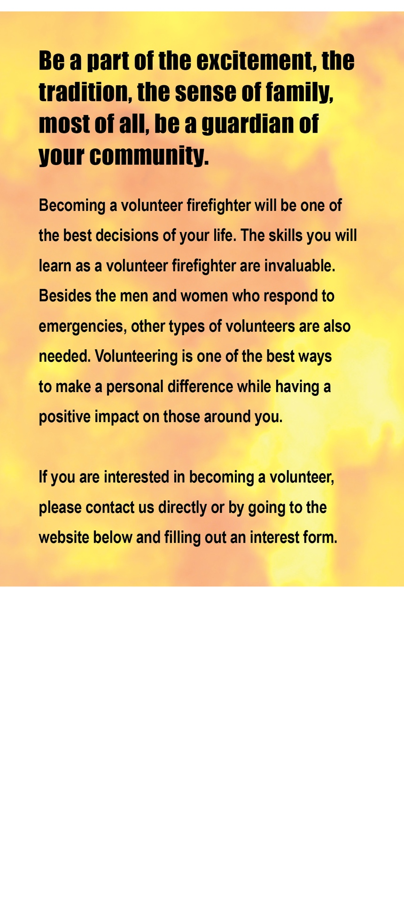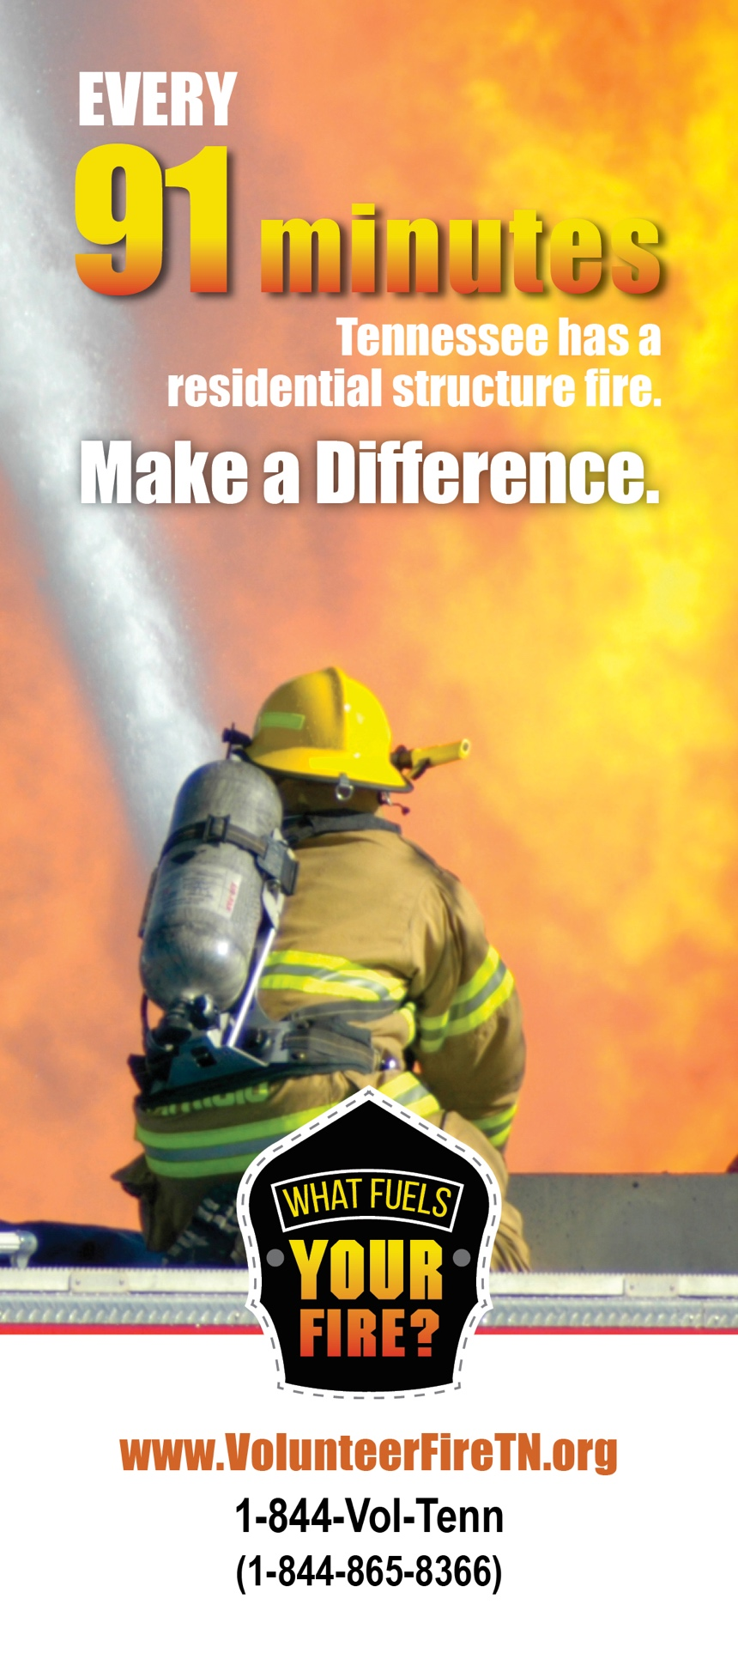

**BECOME A Your Jurisdiction VOLUNTEER FIREFIGHTER.**

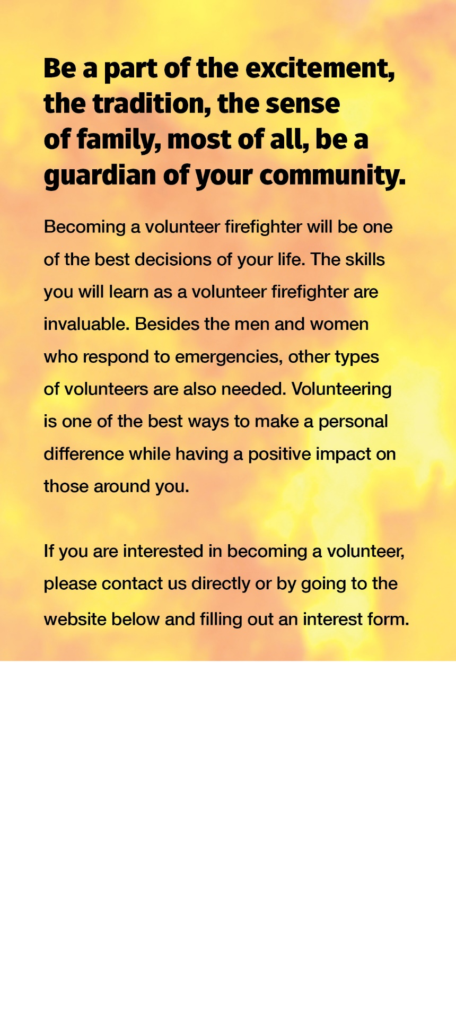

**JOIN Type Your   
Jurisdiction Name**

**123 Sample Rd**

**Sample, TN 12345**

**123-123-1234**