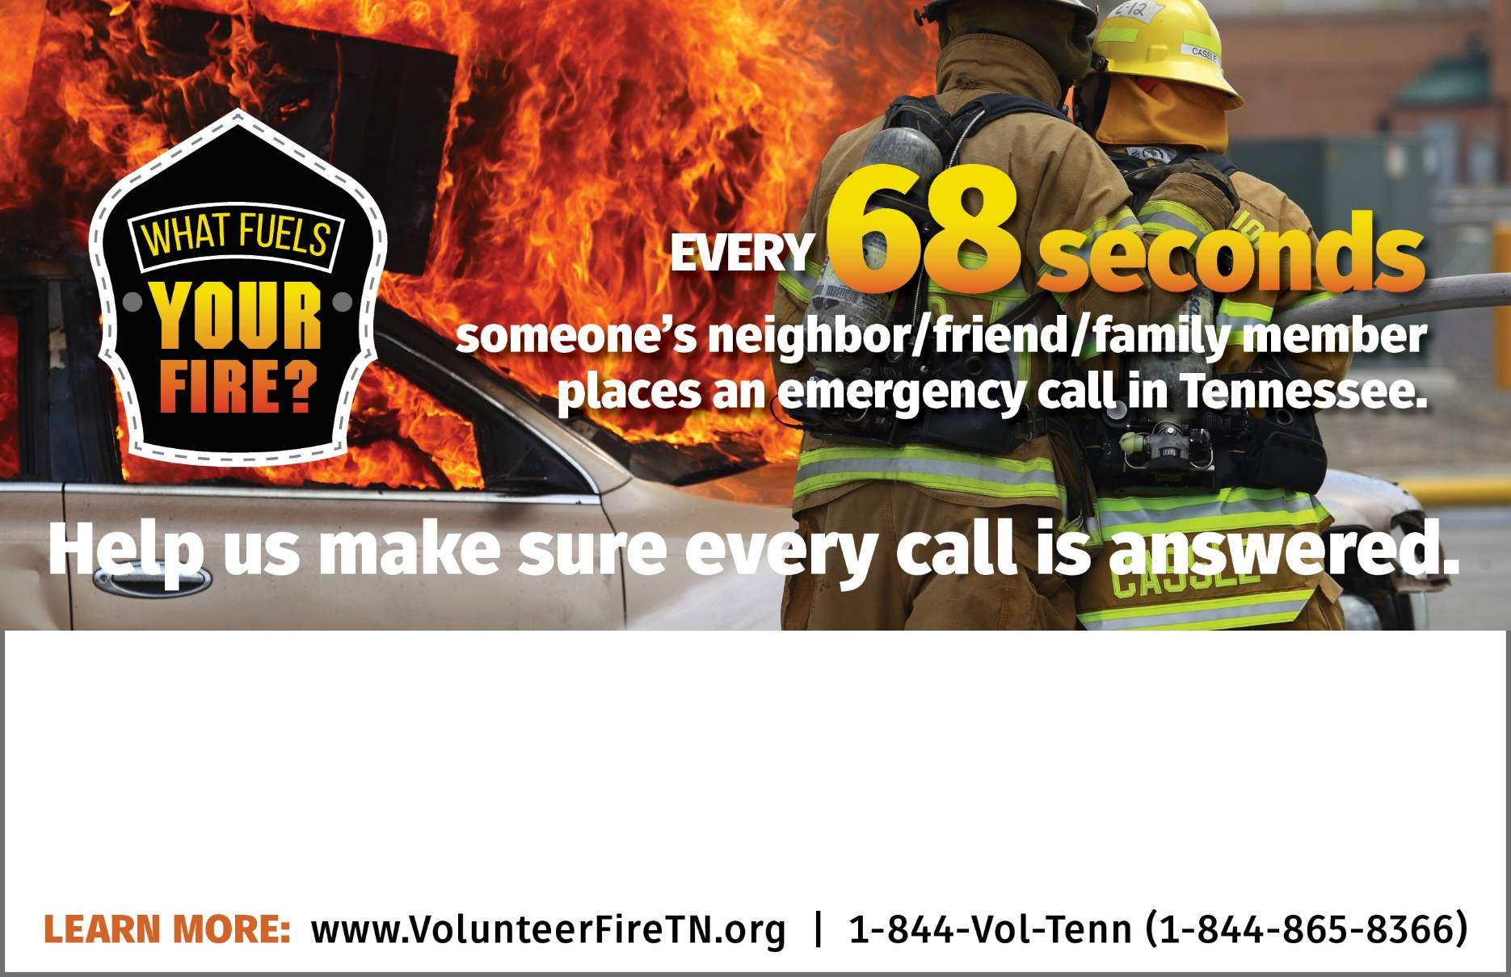

# VOLUNTEER WITH

# type jurisdiction here

**123 Sample Rd • Sample, TN 12345**

**123-123-1234**