

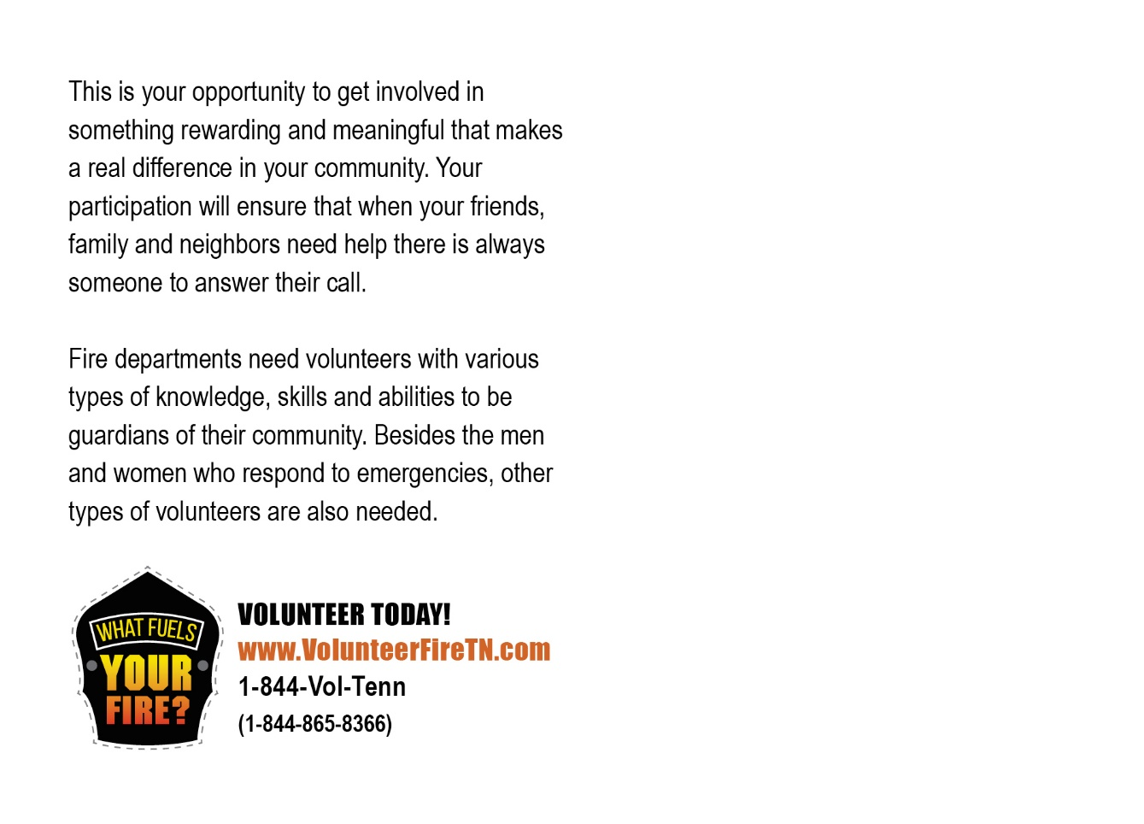

# VOLUNTEER WITH Your Jurisdiction TODAY!

JOIN Your Jurisdiction

**123 Sample Rd • Sample, TN 12345**

**123-123-1234**