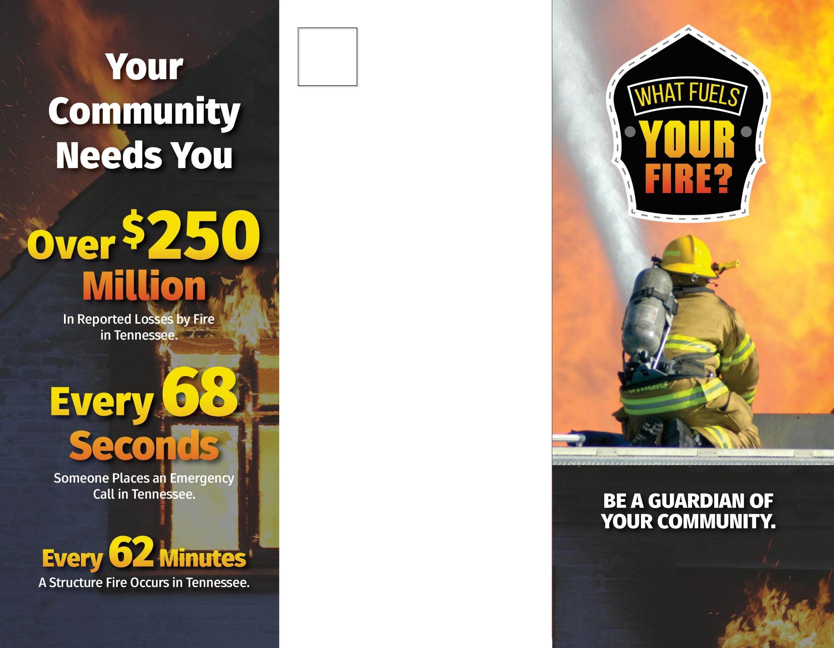

**Your Jurisdiction**

**123 Sample Rd • Sample, TN 12345**

**123-123-1234**

**BE A Your Jurisdiction**

**VOLUNTEER FIREFIGHTER.**

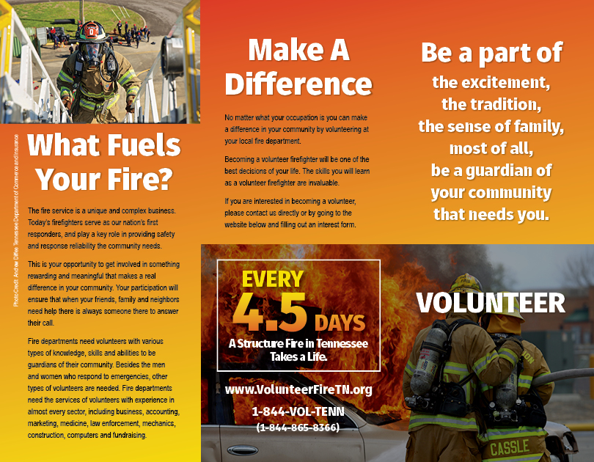

**123 Sample Rd • Sample, TN 12345**

**123-123-1234**

**Your Jurisdiction**