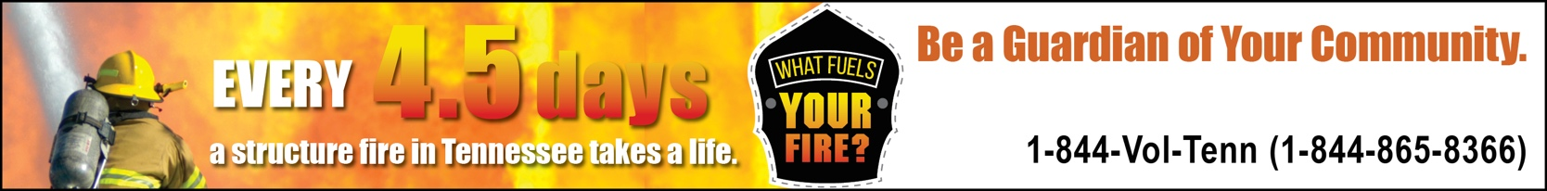

# BE A TYPE YOUR JURISDICTION HERE FIREFIGHTER.

**Be a Sample Volunteer Firefighter.**