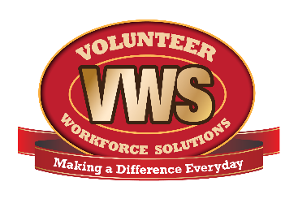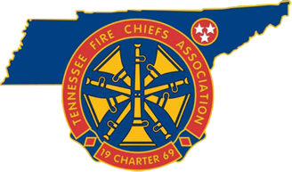
For Immediate Release
September XX, 2018
Contact: Local Contact Name
Local Contact Title
Local Contact phone number

Fall is the Perfect Time to Prepare Your Home to be Fire Safe in Cooler Weather

The leaves are changing color, the morning air is crisp and clean, and many turn their thoughts to holiday time and cold weather activities. Fall is also the perfect time to get a jump on colder weather to make sure your home is fire safe throughout the winter. A little preventative maintenance can go a long way to ensure your home is safe, warm and secure during colder months.
Get your home heating system ready! Schedule an inspection, cleaning and maintenance service in the fall, before the busy season starts and appointments are difficult to get. A properly maintained heating system will deliver the most efficient and reliable source of heat, not only saving on heating bills, but making the chance of a fire much less likely.
If you have a wood or pellet stove, make sure the chimney is thoroughly cleaned of flammable creosote! If the pipe vents directly through the wall, you may be able to clean it yourself with a steel brush. If the pipe extends up to the roof, it is best to have a professional do the job. Your stove will burn cleaner and use less fuel, and your fire risk will be greatly reduced. Don’t forget the stove itself! A good ash vacuum is a great investment and will get your stove in top shape for heating your home throughout fall and winter.
Many homeowners have at least one space heater on hand to use as necessary. Check yours for frayed cords! Make sure the heater is UL certified. Be certain the safety grate is intact and in place. Check the owner’s manual for cleaning instructions. If all checks out, plug in the heater and give it a test run. Don’t wait until you need it to find something wrong. These appliances are usually very affordable. If yours doesn’t seem right, dispose of it and get a replacement. When you do use a space heater, make sure it is away from anything flammable, including curtains, pillows or cushioned furniture.
Have a fireplace? Make sure you get your chimney inspected each year and hire a chimney sweep to clean it out. Check the fireplace for cracks and repair them before you use it. Have a sturdy fireplace screen ready to use to keep sparks and debris inside the fireplace. Never go out and leave a fire burning unattended. Be sure to keep flammable materials at least three feet away from your fireplace. If you have a natural gas fireplace, get all the connections and lines inspected before you use it.
With a little effort you can get your home ready for those first cold days and nights when it’s time to turn on the heat! You’ll not only ensure optimal comfort and cost savings for your family, but you’ll greatly reduce your risk of fire.
For more fall fire safety tips, visit http://bit.ly/fallfiresafety.
Insert your Department name relies on brave men and women to volunteer their time to serve as volunteer firefighters to ensure that every call for help is answered. Men and women with almost every skill set are needed. To learn more about volunteer opportunities, please contact Insert your Department name at Insert website or call Insert your Dept. phone number.
There are volunteer opportunities at your local volunteer fire department for citizens willing to work hard. To learn more about becoming a volunteer firefighter and joining your local volunteer fire department, please visit www.VolunteerFireTN.org.
About the Tennessee Fire Chiefs Association, Inc. (TFCA)
The TFCA provides leadership to career and volunteer Fire Chiefs, Chief Fire Officers and managers of emergency service organizations throughout the State of Tennessee through vision, information, education, service and representation to enhance their knowledge, skills, and abilities. The TN Fire Chiefs Association (TFCA) also encourages the professional advancement of the fire service to ensure and maintain greater protection of life and property from fire and natural or man-made disasters. The TFCA’s mission is to provide leadership to career and volunteer chiefs, chief fire officers, and managers of Emergency Service Organizations throughout the State of Tennessee through vision, information, education, service and representation to enhance their professionalism and capabilities. More information about the TFCA is located at www.tnfirechiefs.com .
About Volunteer Workforce Solutions (VWS)
The Tennessee Fire Chiefs Association was awarded a SAFER recruitment and retention grant in 2016 and partnered with the International Association of Fire Chiefs to identify recruitment and retention goals, strategies and marketing methodologies that would benefit not only participating departments, but all fire departments in the state. 19 departmental groups, consisting of 64 departments, were selected to participate in Phase I of the program. The VWS program is also operating in Virginia through the Virginia Fire Chiefs Association and Connecticut through the Connecticut Fire Chiefs Association. There is also currently a National VWS effort focusing on diversity and new trainings. More information about the Tennessee VWS can be found at www.VolunteerFireTN.org.
(Insert info about your department in similar format to above)

