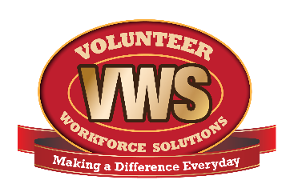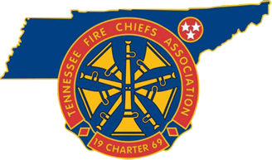
For Immediate Release
October XX, 2017
Contact: Local Contact Name
Local Contact Title
Local Contact phone number
October is Fire Safety Awareness Month
Insert your town, TN, October XX, 2017 October is Fire Safety Awareness Month. Sponsored by the National Fire Protection Association (NFPA), Fire Prevention Week 2017 falls within the month from the 8th through the 14th. This year’s theme is, “Every Second Counts: Plan 2 Ways Out!”
In a fire, every second counts. It has been shown that with today’s construction methods and synthetic materials used in modern furnishings, families have less than three minutes to escape a fire before flashover occurs. Flashover is when furniture and floor coverings in a room reach ignition temperature almost simultaneously and burst into flame. The temperature at which flashover happens is approximately 1100°F. When flashover ensues, everything in the room is on fire and temperature in the room reaches its maximum.
What can you do to keep your family safe from the ravages of a home fire? NFPA recommends the following preventative measures:
- Draw a map of your home with all members of your household, marking two exits from each room and a path to the outside from each exit.
- Practice your home fire drill twice a year. Conduct one at night and one during the day with everyone in your home, and practice using different ways out.
- Teach children how to escape on their own in case you can’t help them.
- Make sure the number of your home is clearly marked and easy for the fire department to find.
- Close doors behind you as you leave – this may slow the spread of smoke, heat, and fire.
- Once you get outside, stay outside. Never go back inside a burning building.

Fire Prevention Week was created to commemorate the Great Chicago Fire. On the 40th anniversary (1911) of the Great Chicago Fire, the Fire Marshals Association of North America (FMANA); NFPA’s oldest membership section, sponsored the first National Fire Prevention Day, deciding to observe the anniversary as a way to keep the public informed about the importance of fire prevention. This was expanded to Fire Prevention Week in 1922.
When President Calvin Coolidge proclaimed the first National Fire Prevention Week in October of 1925, he noted that in the previous year some 15,000 lives were lost to fire in the United States. Coolidge's proclamation stated: "This waste results from the conditions which justify a sense of shame and horror; for the greater part of it could and ought to be prevented... It is highly desirable that every effort be made to reform the conditions which have made possible so vast a destruction of the national wealth"
Over 90 years later, President Coolidge’s words still ring true. For more information about fire prevention week, and to learn more about NFPA’s “2 Ways Out” campaign, visit http://bit.ly/2evj22O.
Insert your Department name relies on brave men and women to volunteer their time to serve as volunteer firefighters to ensure that every call for help is answered. Men and women with almost every skill set are needed. To learn more about volunteer opportunities, please contact Insert your Department name at Insert website or call Insert your Dept. phone number.
There are volunteer opportunities at your local volunteer fire department for citizens willing to work hard. To learn more about becoming a volunteer firefighter and joining your local volunteer fire department, please visit www.VolunteerFireTN.org.
About the Tennessee Fire Chiefs Association, Inc. (TFCA)
The TFCA provides leadership to career and volunteer Fire Chiefs, Chief Fire Officers and managers of emergency service organizations throughout the State of Tennessee through vision, information, education, service and representation to enhance their knowledge, skills, and abilities. The TN Fire Chiefs Association (TFCA) also encourages the professional advancement of the fire service to ensure and maintain greater protection of life and property from fire and natural or man-made disasters. The TFCA’s mission is to provide leadership to career and volunteer chiefs, chief fire officers, and managers of Emergency Service Organizations throughout the State of Tennessee through vision, information, education, service and representation to enhance their professionalism and capabilities. More information about the TFCA is located at www.tnfirechiefs.com .
About Volunteer Workforce Solutions (VWS)
The Tennessee Fire Chiefs Association was awarded a SAFER recruitment and retention grant in 2016 and partnered with the International Association of Fire Chiefs to identify recruitment and retention goals, strategies and marketing methodologies that would benefit not only participating departments, but all fire departments in the state. 19 departmental groups, consisting of 64 departments, were selected to participate in Phase I of the program. The VWS program is also operating in Virginia through the Virginia Fire Chiefs Association and Connecticut through the Connecticut Fire Chiefs Association. There is also currently a National VWS effort focusing on diversity and new trainings. More information about the Tennessee VWS can be found at www.VolunteerFireTN.org.
(Insert info about your department in similar format to above)

