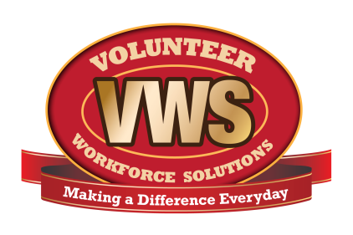
Fire Department Name
Address
City, State ZIP Code
Your logo here

Name: Date:

Exit Interview

- What was the most important factor in your decision to leave the fire department?

- Did your training officer demonstrate fair and equal treatment?

- Did your training officer encourage and listen to your suggestions?

- Did your training officer hold regular meetings to give me feedback on your performance?

- Who was your mentor?

- Did your mentor provide direction and assistance to you when needed?

- How would you rate communication within the department?

- How would you rate the training you received?

- Were training and duty expectations clearly and accurately explained when you initially applied?

- What did you like most about being a member of the department?

- What did you like least about being a member of the department?

- Do you have any additional comments?

