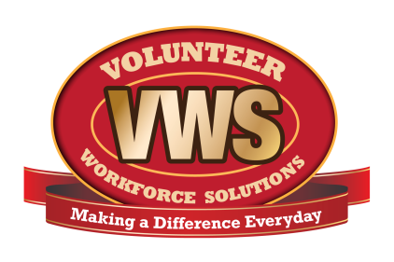
Dept. logo here
Fire Department Name
Address
City, State ZIP Code

Date

Name
Street Address
City, State, ZIP Code

Dear (Name),

We have received and reviewed your application to volunteer at the (department name) Fire Department.

At this time, we are holding your application for consideration in our next recruitment class, which will begin on or about (date). Prior to that time, we will contact you to schedule an interview.

In the meantime, please continue to visit our website, www. , for the latest news and information. You can also follow us on Facebook at (Facebook Page name).

Thank you again for your interest in serving your community.

Sincerely,

(Signatory Name)
The (department name) Fire Department Recruitment Committee

