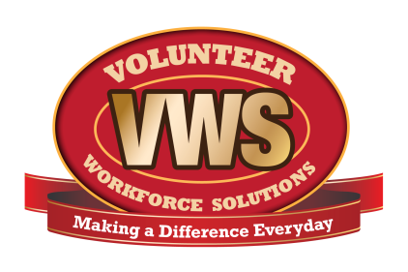
Fire Department Name
Address
City, State ZIP Code
Dept. logo here

Date

Name
Street Address
City, State, ZIP Code

Dear (Name),

We have received and reviewed your application to join the (department name) Fire Department. However, before we can schedule an interview we need some additional documents that were omitted from your original application.

The following documents are missing.

Completed Application
Criminal Background Check Form
Fit to Serve Form
Medical History Form
Copy of Your Current Physical

Copies of these documents can be found on our website (http://www. ) by clicking on the Recruitment link located on the main menu.

Please complete the missing form(s) and return to:
Recruiter’s Name
Address
City, State ZIP Code

If you have questions, please call: (Name and phone number)
We look forward to reviewing your application.

Thank you again for your interest to serve the community.

Sincerely,

(Signatory Name)
The (department name) Fire Department Recruitment Committee

